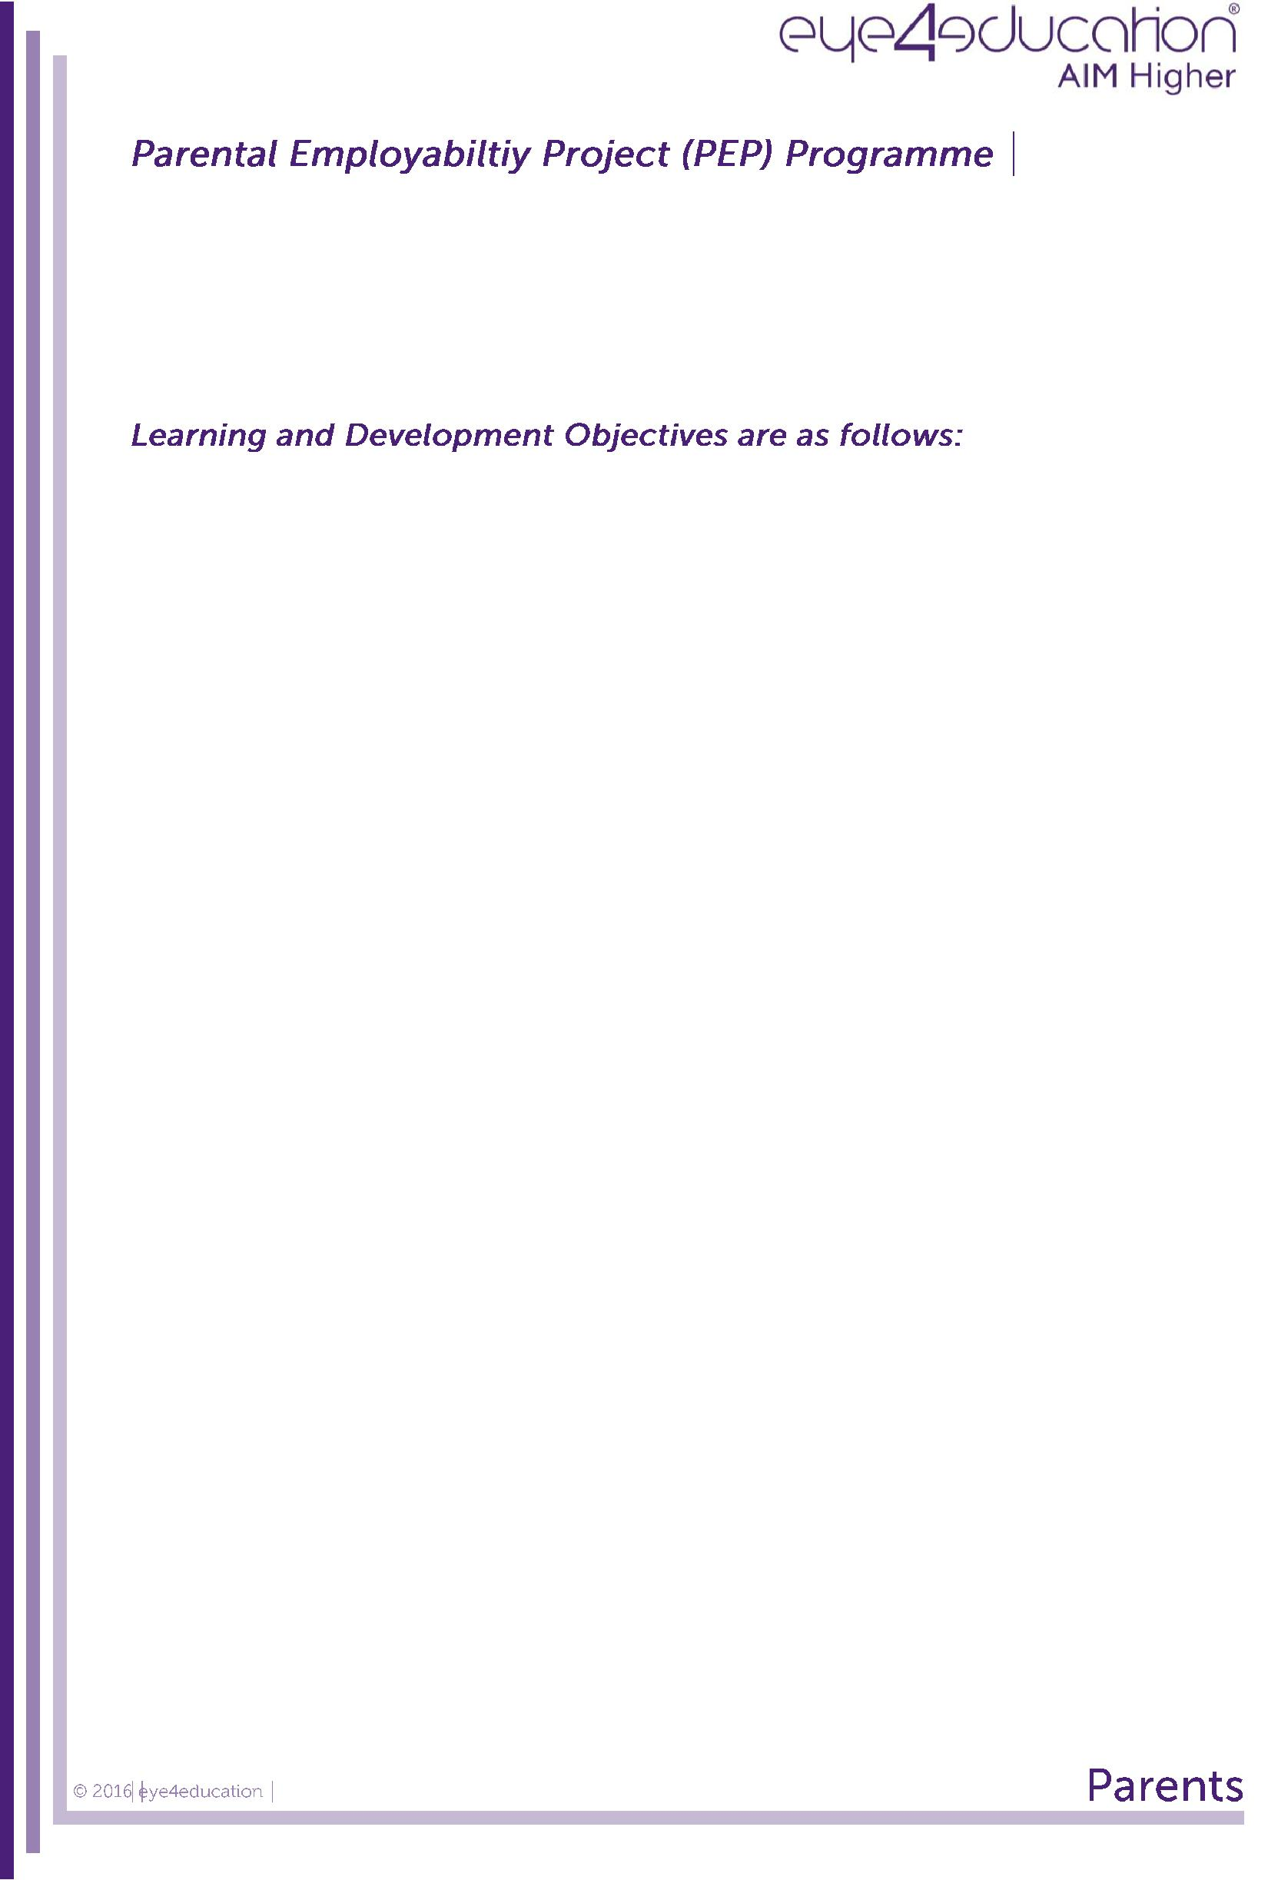

The Parental Employability Project is designed to provide parents, carers and extended family with information, education, advice and guidance on the STEM agenda and current/future labour market information within Northern Ireland. This will focus on students’ routes to progression and the demand for employees especially in STEM companies however covering both STEM and non-STEM related employment.

Awareness of the importance of parental engagement

Awareness of future demand and supply within the NI labour market and qualifications demand by employers

Understanding of the progression routes for students – from Year 10 through to the job market – including alternative routes

Understanding the impact STEM companies will have on the future labour market

Demonstration of the importance of employees with non-STEM backgrounds within STEM companies

Provision of online resources to facilitate parental use in advising their child

The school will receive a group report based on a pre and post check of learning and development objectives, conducted utilising Qwizdom keypad technology. This will demonstrate the change in skills, knowledge and attitude of the participant as a result of the delivery.

The delivery uses specific content and context material relating to Northern Ireland (and occasionally global).

 | Session |  |  |  | Content |  |  |  | Materials |  |  |  | Timing
 | Time
 | 7.00 – 8.00pm

 |  |  |  |  | Parental Employability Project |  |  |  | PowerPoint
 |  |  |  |  |  |  |  |  |  |  |  |  | 10
 | 7.00 -7.10 |  |  |  | Introduction and Overview |  |  |  | Qwizdom
 |  |  |  |  |  |  |  |  |  |  |  |  | minutes
 |  |  |  |  | Pre Learning and Development Check |  |  |  | Keypads
 |  |  |  |  | Session 1
 | 7.10 - 7.15 |  |  |  | Why Parental Engagement is so |  |  |  | PowerPoint |  |  |  | 5 minutes
 |  |  |  |  | important!
 |  |  |  |  | Session 2
 | 7.15 - 7.30 |  |  |  | UK and NI Labour Market Trends – |  |  |  | PowerPoint |  |  |  | 15
 |  |  |  |  | Statistics Review |  |  |  | Hand-outs |  |  |  | minutes
 |  |  |  |  | Qualifications Demand by employers
 |  |  |  |  | Session 3
 | 7.30 – 7.40 |  |  |  | Alternative Qualifications |  |  |  | PowerPoint |  |  |  | 10
 |  |  |  |  | Progression Routes to the Job Market |  |  |  | Activity Sheet |  |  |  | minutes
 |  |  |  |  | Local and National Case Studies
 |  |  |  |  | Session 4
 |  |  |  |  | STEM Companies – Growth in STEM |  |  |  | PowerPoint
 |  |  |  |  | Companies |  |  |  |  |  |  |  | 10
 | 7.40 – 7.50 |  |  |  |  |  |  |  | Qwizdom
 |  |  |  |  | Importance of employees with non-STEM |  |  |  |  |  |  |  | minutes
 |  |  |  |  |  |  |  |  | Keypads
 |  |  |  |  | backgrounds
 |  |  |  |  | within STEM companies
 |  |  |  |  | Session 5
 |  |  |  |  | Resources:
 | 7.50 – 7.55 |  |  |  | - Parents resource area on |  |  |  | PowerPoint |  |  |  | 5 minutes
 |  |  |  |  | eye4education website
 |  |  |  |  | - Other useful websites
 |  |  |  |  | Session 6
 |  |  |  |  | Post Learning and Development Check |  |  |  | PowerPoint
 | 7.55 – 8.00 |  |  |  | Q and A |  |  |  | Qwizdom |  |  |  | 5 minutes
 |  |  |  |  | Next Steps |  |  |  | Keypads
 |  |  |  |  | Close

